DATA ANALYTICS
PROJECT DOCUMENTATION
Data Cleaning | EDA | KPIs | Dashboard | Recommendations

Project Name: | HR Analytics & Employee Attrition Analysis | Analyst Name: | Muhammad Saad
Dataset Name: | HR_Employee_Data_2024 | Date Submitted: | 07/05/2026
Tool(s) Used: | Excel / Power BI / SQL | Reviewed By: | Ali Laghari
Department: | HR | Version: | v1.1

SECTION 1 — PROJECT OVERVIEW

1.1 Business Problem Statement
Describe WHY this analysis was done. What problem are we solving?

Business Problem:
The company is facing rising employee attrition and HR leadership cannot identify:
Business Questions to Answer:
- Which departments and job roles are losing the most employees
- Whether salary, age, or experience level is linked to attrition
- Whether employee satisfaction scores predict who will leave
- What the overall attrition rate is and how it compares across departments
- Which employees are at risk of leaving next

1.2 Dataset Overview
Summarize the dataset before you do anything to it.

Property | Details
File Name | HR_Employee_Data_2024
Total Rows (Raw) | 252 Rows
Total Columns | 14 columns
Date Range | 2024
Data Source | HR ERP System
Key Columns | ' Employee_ID ' , Age', 'Department', 'Job_Role',  'Monthly_Salary_PKR', 'Performance_Rating',  'Job_Satisfaction', 'Attrition'
Format | .xlsx

SECTION 2 — DATA CLEANING LOG

This is the most critical section. Document EVERY issue found and EVERY fix applied. A dashboard is only as trustworthy as the data behind it.

2.1 Data Quality Issues Found
S.NO | Issue Type | Column Affected | Count Found | Example | Action Taken | Status
1 | Missing Values | Performance_Rating | 12 rows | NULL | Replaced with column average | Fixed
2 | Missing Values | Job_Satisfaction | 14 rows | NULL | Replaced with Column Average | Fixed
3 | Duplicate Records | Employee_ID | 2 duplicates | Emp010,  Emp025  appeared twice | Removed duplicate rows, kept first occurrence | Fixed
4 | Inconsistent Format | Gender | 15 rows | Male , m  Female , f | Standardized all to Title Case using PROPER() / Find & Replace | Fixed
6 | Invalid Value | Monthly_Salary_PKR | 4 rows | Negative quantities (-0, -1000,-5000) | Fixed With the Confirmation of HR | Fixed
7 | Outliers | Age | 2 rows | 7, 99 | Fixed With The Confirmation of HR  New Age 27,39 | Fixed

2.2 Data Cleaning Summary

Metric | Value
Total Raw Rows | 252 Rows
Rows Removed (duplicates/invalid) | 2 Rows
Rows After Cleaning | 250 Rows
Columns Modified | 6 columns
Missing Values Handled | 26 cells
Cleaning Tool Used | Excel Power Query / Python
Time Taken to Clean | 1.5 hours

SECTION 3 — EXPLORATORY DATA ANALYSIS (EDA)

Summarize key patterns, distributions, and anomalies found during exploration. Support each finding with a number.

3.1 Key Findings
Attrition Overview

# | Finding | Supporting Data / Number
1 | Department With High Attrition Rate | Operations 60.8
2 | Department With Lowest Attrition Rate | HR 40.1
3 | Attrition Rate By Male | Male 50.7
4 | Attrition Rate By Female | Female 56.6

3.2 Department Overview
Department | Total Employees | Active Employees | Left Employees | Attrition Rate
Operations | 51 | 20 | 31 | 60.78
Sales | 43 | 18 | 25 | 58.14
IT | 57 | 26 | 31 | 54.39
Finance | 43 | 20 | 23 | 53.49
HR | 56 | 33 | 23 | 41.07
TOTAL | 250 | 117 | 133 | 53.20

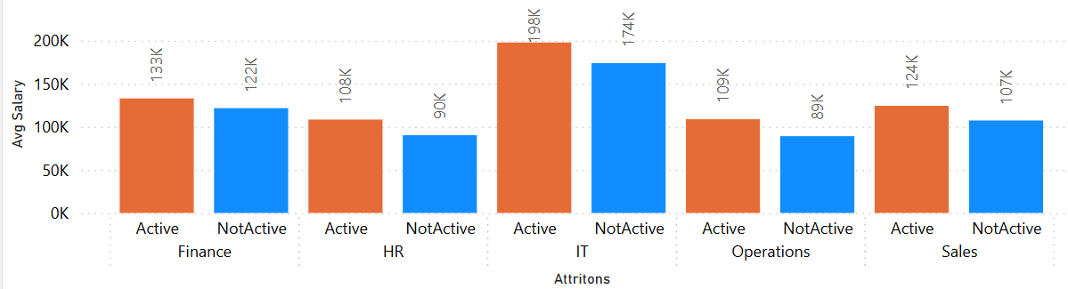
3.3 Active Vs Non Active Members Avg Salary Comparison
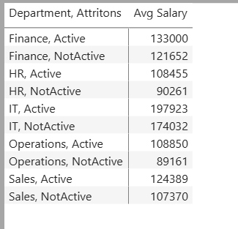

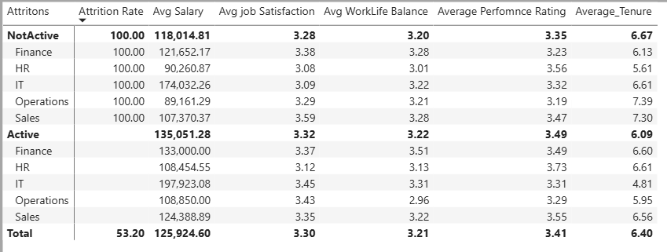
3.4 Active Vs Non Active Members Performance Comparison By Department

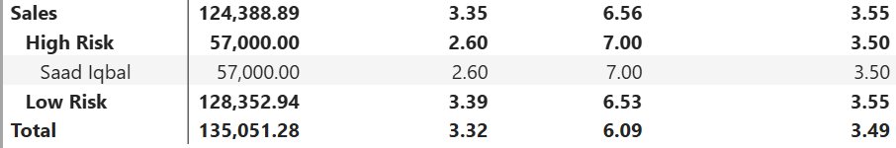
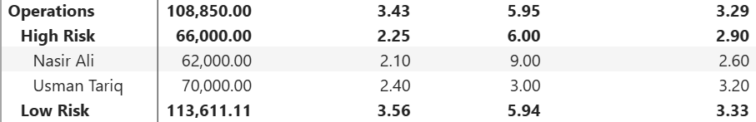
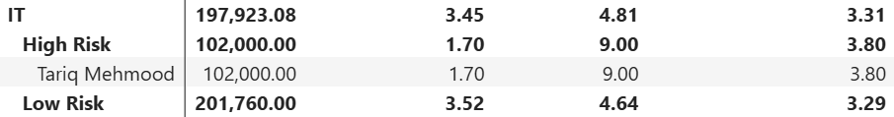
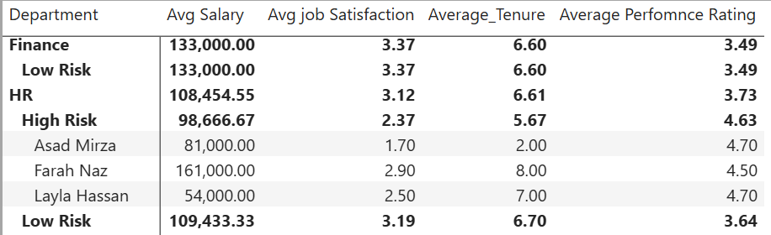
3.4 Risk Analysis

3.5 Anomalies / Red Flags Found
Things that look unusual and may need further investigation.

Anomaly | Possible Reason | Recommended Action
Operation Department Attrition Rate Extremely High Operation Executive Job Role Attrition Rate Extremely High only 6 Employees Active now out of 20 | Underperforming?  Not Satisfied | Verify with manager

SECTION 4 — KPI CALCULATIONS

Show the formula, the result, and what it means for the business. Never just write a number — explain it.

4.1 KPI Summary Table
KPI Name | Formula | Result | Business Meaning
Total Employees | Counta([Employee_ID] | 250 | Overall Employees
Active Employees | Calculate([Total Employees],[Attrition=”No”]) | 117 | No: of Employees Who Are Active Yet
Left Employees | Calculate([Total Employees],[Attrition=”Yes”]) | 133 | No: of Employees Who Left Us
Attrition Rate % | Attrition Rate = [Left Employees]/[Total Employees]*100 | 53.20 | Overall Attrition Rate
Leaver Tenure | Average Tenure = CALCULATE(AVERAGE(HR_Employee_Data[Years_at_Company]) , HR_Employee_Data[Attrition]="Yes") | 6.67 | Avg Working tenure of Leaver
Avg Salary | Avg Salary = AVERAGE(HR_Employee_Data[Monthly_Salary_PKR]) | 125.92k | Average Salary

SECTION 5 — DASHBOARD DOCUMENTATION

5.1 Dashboard Overview
Property | Details
Tool Used | Power BI | Excel
Dashboard Title | Employees Attrition and Workforce Analysis Dashboard
No. of Pages | 1 Attrition Overview , 2 Deep Analysis
Slicers / Filters | Department
Data Refresh | Static snapshot
File Name | HR_Employee_Data_2024

5.2 Visuals Included
# | Visual Type | Title / Description | Data Fields Used | Purpose
1 | Line Chart | Attrition Rate By Department | Attrition Rate, Departemnt | Show Attrition Rate Trend
2 | Bar Chart | Revenue by City | Store_City, Total_Sales | Compare store performance
3 | Donut / Pie | Attrition Rate By Gender | Gender, Attrition | Show Attrition by Gender
4 | KPI Card | Total Employees | Sum([EmpId]) | Total Employees
5 | KPI Card | Active Employees | Calculate([Total Employees],[Attrition=”No”]) | Active Employees
6 | Table Matrix | Department Overview | Show Department, Jobe Role,Avg tenure, Avg job Satsifaction | Identify Attrtion Rate By Department
7 | [Add visual] | [Name] | [Fields] | [Purpose]

5.3 Design Decisions
Explain any design choices you made:
- Color theme chosen: Orange
- Font used:Arial for readability
- Department Slicer Is used to filter out Data by Departement

SECTION 7 — Key Recommendation
Focus on High Attrition Departments

Operation Sales and IT Department Shown high Attrition Rate
- Conduct employee feedback sessions
- Identify workload and management issues
- Improve employee engagement programs

Improve Work-Life Balance

Employees with lower work-life balance scores show higher attrition risk.
- Reduce excessive overtime
- Introduce flexible work policies
- Monitor employee burnout indicators

Increase Employee Satisfaction

Lower job satisfaction is strongly linked with employee exits.
- Conduct quarterly satisfaction surveys
- Improve recognition and reward systems
- Provide clear career growth opportunities

Review Promotion Policies

Employees with longer gaps since last promotion appear more likely to leave.
- Create transparent promotion criteria
- Introduce performance-based growth plans
- Conduct regular career development discussions

Executive Summary

The analysis indicates that employee attrition is influenced by factors such as low job satisfaction, poor work-life balance, overtime, and delayed promotions. Departments with higher attrition require targeted retention strategies, while organization-wide improvements in employee engagement, career growth, and workload management may help reduce turnover and improve workforce stability

SECTION 6 — SIGN-OFF & VERSION CONTROL

7.1 Version History
Version | Date | Author | Changes Made
v1.0 | 07/05/2026 | Muhammad Saad | Initial draft — data cleaning + EDA
v1.1
v2.0

7.2 Approval Sign-Off
Role | Name | Signature | Date
Analyst (Prepared By) | Muhammad Saad | ___________ | 07/05/2026
Manager (Reviewed By) | [Manager Name] | ___________ | [Date]
Head of BI (Approved By) | [Director Name] | ___________ | [Date]

Pro Tip for Every Project
Data tells a story. Your job is to find it, clean it, and present it with confidence.
Always document as you go — not after the fact.

